Step by step guide Nurse and Healthcare workers

1. The user logs on at the start of his or her shift (only needs to logon one time).

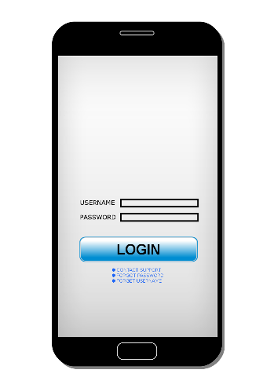

1. The assignment list is displayed with GPS coordinates for navigation.

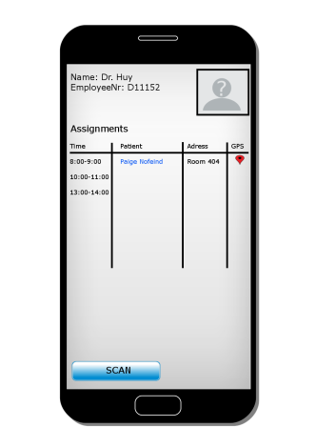

1. When the user is at the patients location he or she scans the QR code on the inside of the patients door to log arrival time and get the patients info, work assignment and messages from, doctor, family, healthcare worker or other nurse.

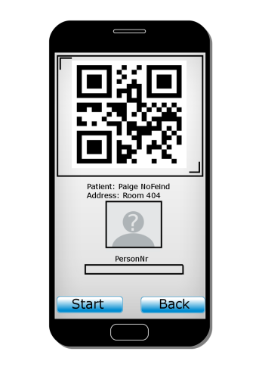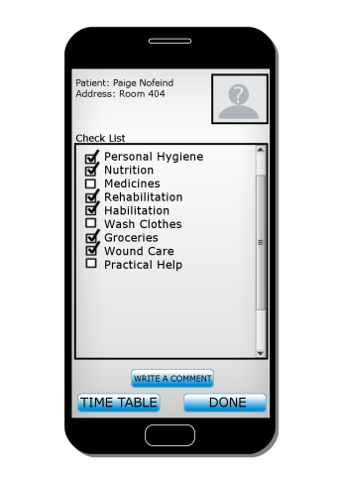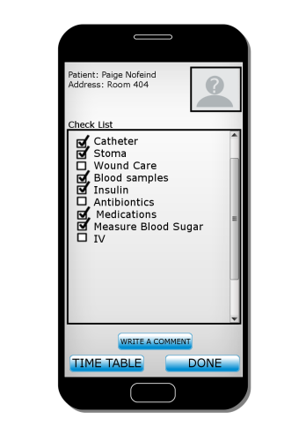

1. After completing the task the user checks the boxes and adds comment witch are viewable only to the persons checked in the list. So that only the people that need to see the comments get them. The comment section also supports pictures so it is easy to track wounds or infection. The user only needs to write the comment one time and share it with the relevant people. It is also possible to order food from kolonial.no that delivers food home to the patient. The family can also order and see what has been ordered and delivered.

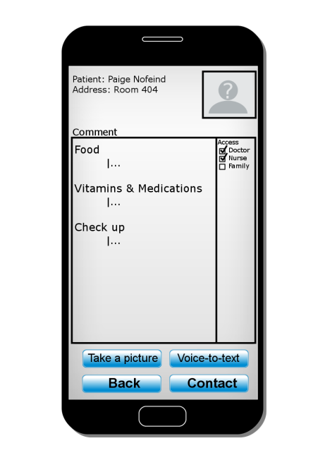

1. The user scans the QR code again when leaving and the out time is logged. The family can easily see what work has been done, timetable and relevant comments.